BIO 203: Biological Techniques
Preparation for Dissection
Dissection is a cornerstone of biological techniques, allowing hands-on exploration of anatomical structures that textbooks alone cannot convey. However, preparation is critical to ensure the procedure is safe, ethical, and scientifically productive. Poor preparation can lead to inaccurate observations, safety hazards, or ethical violations.
Dissecting steps include:
- Orientation
- Place the rat ventral (belly) side up on the dissecting tray, secured with pins through the paws.
- Identify sex: Males have scrotal sacs; females have nipples and a vaginal opening.
- Measure overall: Length (nose to tail base) in cm; weight in gram.

External Observations
Examine and document:
Feature | Description | Function/Notes
Fur | Short, gray-brown; sparse on belly | Thermoregulation; note any preservation artifacts
Incisors | Prominent upper/lower; yellow-orange | Gnawing adaptation; check occlusion
Limbs | Four clawed digits on forepaws; five on hind | Locomotion; observe muscle definition
Tail | Long, scaly, hairless | Balance; measure separately (~15 cm)
Anus/Urogenital | Posterior openings | Sex determination landmark
Sketch Tip: Draw a labeled dorsal/ventral view.
Note: "Specimen appears well-preserved; minimal tissue shrinkage."
- Initial Incisions and Skinning
Begin with superficial cuts to access the body wall.

Tools
Scalpel (blade), forceps (fine-tip), scissors, probe, pins.

Step-by-Step Procedure
- Midline Incision: Using the scalpel, make a shallow cut (1-2 mm deep) from the base of the sternum (breastbone) to 1 cm anterior to the anus. Angle the blade perpendicular to the skin; use forceps to lift skin as you cut. Avoid penetrating muscle.
- Transverse Cuts: At the superior end (neck), cut laterally across the shoulders (~2 cm from midline). At the inferior end (pelvis), cut across the hips. Connect these to form a "T" or "U" flap.
- Skin Reflection: Gently tease the skin away from underlying muscle using forceps and probe. Pin the skin flaps outward to expose the abdominal musculature. (The skin should peel like a jacket do not tear.)
Observation Point: Note the thin, transparent peritoneum lining the cavity. Measure incision length in cm midline.
Safety Note: Keep fingers clear of blade path; dispose of used blades in sharps container immediately.

Abdominal Cavity – Digestive and Associated Systems

Opening the Abdomen
- Muscle Incision: Cut through the abdominal wall along the same midline line, stopping at the diaphragm (superior) and pubic symphysis (inferior). Use scissors for thicker muscle.
- Peritoneal Reflection: Pin the muscle flaps laterally. Probe gently to identify organs without displacing them.

Key Structures and Identification
Proceed systematically from anterior to posterior:
Technique Tip: Use probe to separate fatty connective tissue without tearing. Rinse cavity with saline if needed for clarity.
Documentation: Sketch abdominal layout.
Thoracic Cavity – Circulatory and Respiratory Systems

Opening the Thorax
- Diaphragm Cut: Extend midline incision through the diaphragm (dome-shaped muscle) to the sternum base. Cut laterally along ribs if needed.
- Sternum Removal: Use scissors to snip costal cartilage along one side of the sternum; fold or remove the bone flap to expose the cavity. (Alternative: Cut ribs bilaterally for a "window.")

Urogenital System
Access posterior structures; may require repositioning.

Exposure
- Bladder/ Kidneys: Locate in lower abdomen; gently displace intestines anteriorly with cotton or probe.
- Gonads: Trace from kidneys.
Sex-Specific Note: Females show uterine bifurcation; males have prostate/seminal vesicles near bladder.

Nervous System Overview
- Spinal Cord: Trace along vertebral column (do not decapitate unless advanced).
- Sciatic Nerve: Probe large nerve in hindlimb.
- Brain (Optional): If time, make dorsal head incision to expose cerebrum/cerebellum.
Documentation: Note nerve branching patterns.
- Cleanup and Post-Dissection Procedures

Steps
- Preservation: If reusing, re-pin and cover with damp towel; store in formalin.
- Disposal: Double-bag remains in biohazard bags; label and place in designated waste.
- Station Cleanup: Disinfect surfaces with 70% ethanol; return tools to kit (sharpen/replace blades).
- Personal Hygiene: Remove PPE, wash hands for 20 seconds.

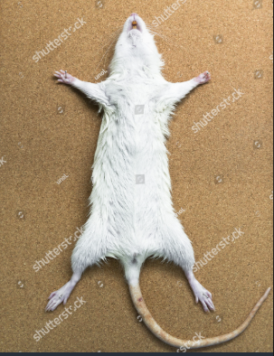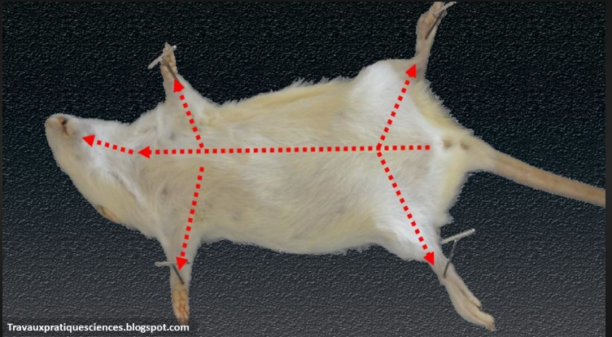
Fig 1: Orientation layout Fig 2: Incision Line

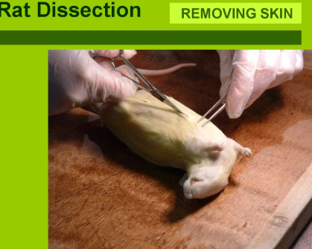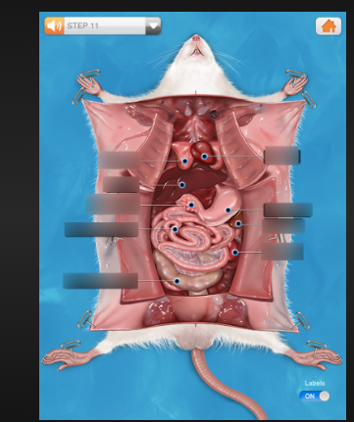
Fig 3: Remove fur Fig 4: Cut open through the incision line

